Assignment 4 - B11-5A1E

Chandni G

2019103514

BE CSE, Batch P, College of Engineering, Guindy, Anna University

Assignment Kubernetes / Docker

1. Pull an Image from docker hub and run it in docker playground.
2. Create a docker file for the jobportal application and deploy it in Docker desktop application. 3.Create an IBM container registry and deploy helloworld app or jobportalapp.

4.Create a Kubernetes cluster in IBM cloud and deploy helloworld image or jobportal image and also expose the same app to run in nodeport.

1. Pull an Image from docker hub and run it in docker playground.

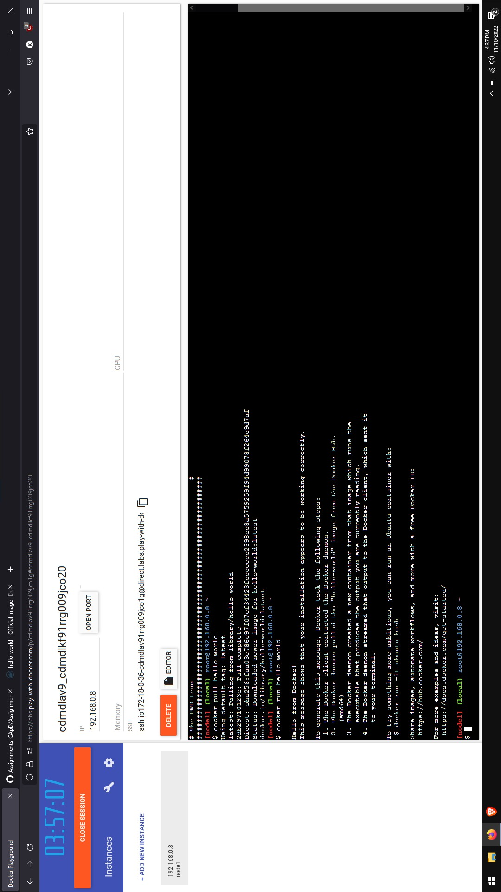

1. Create a docker file for the jobportal application and deploy it in Docker desktop application.

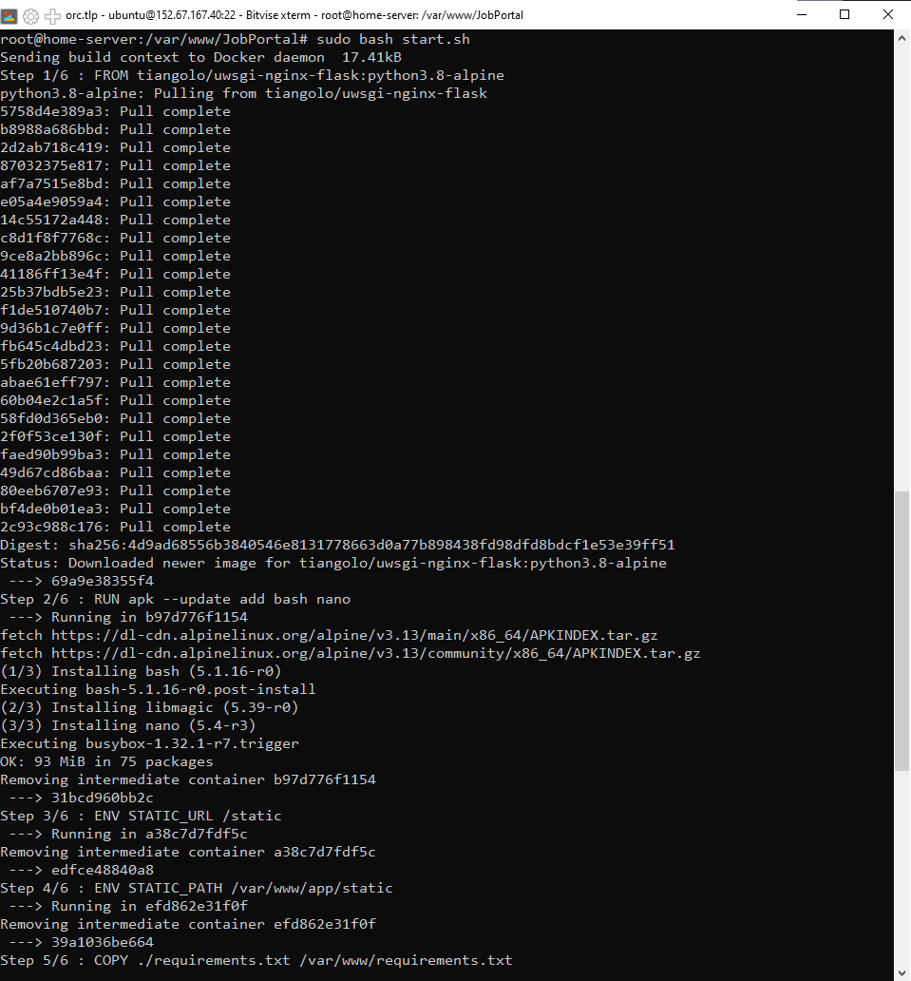

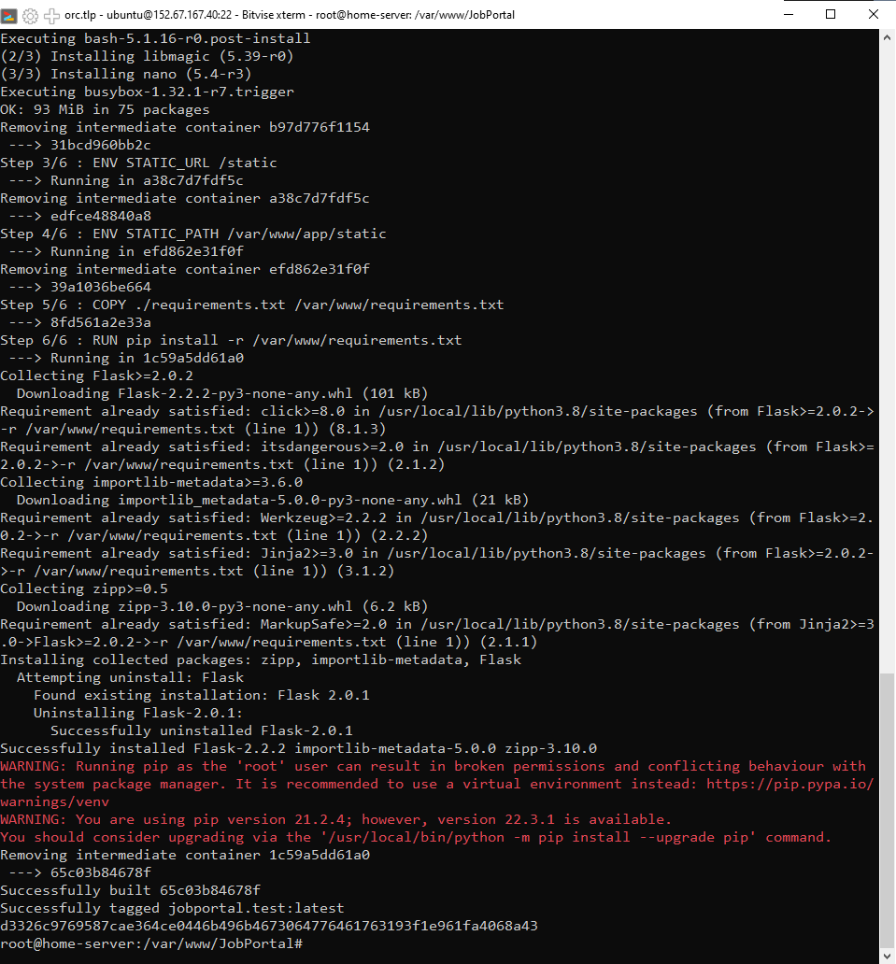

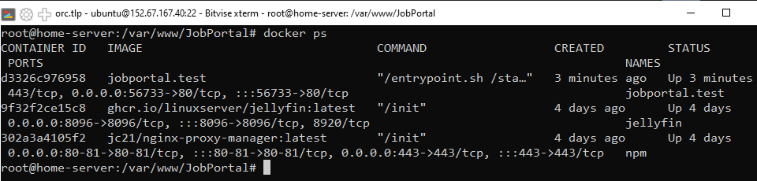

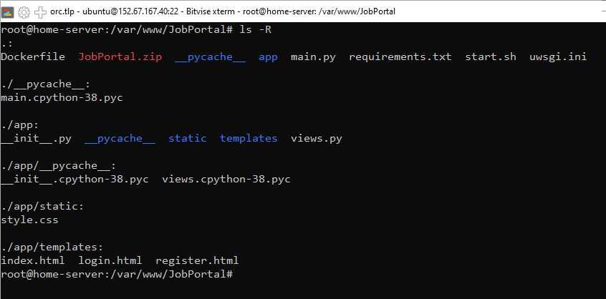

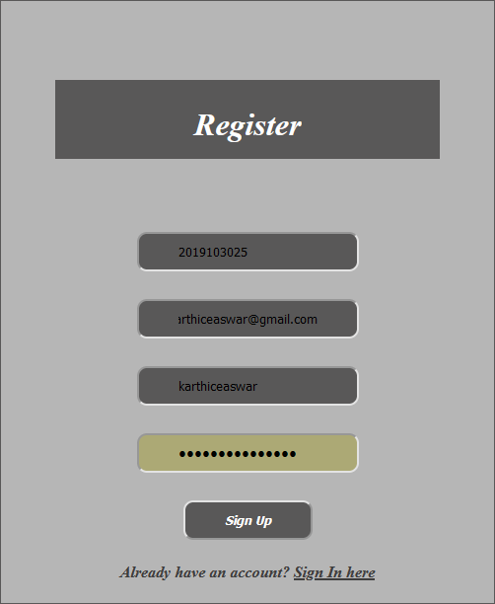

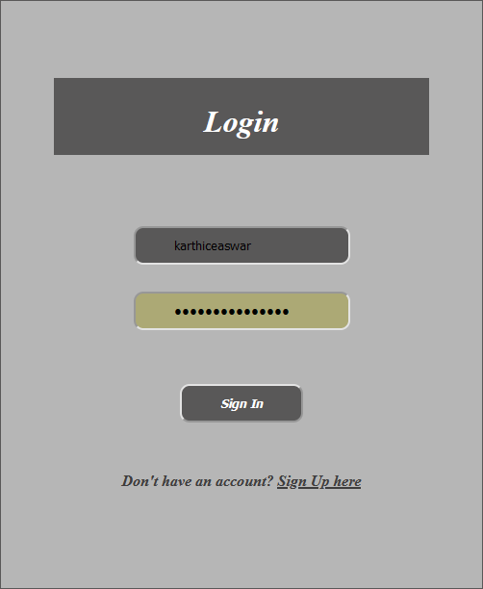

1. Create an IBM container registry and deploy helloworld app or jobportalapp.

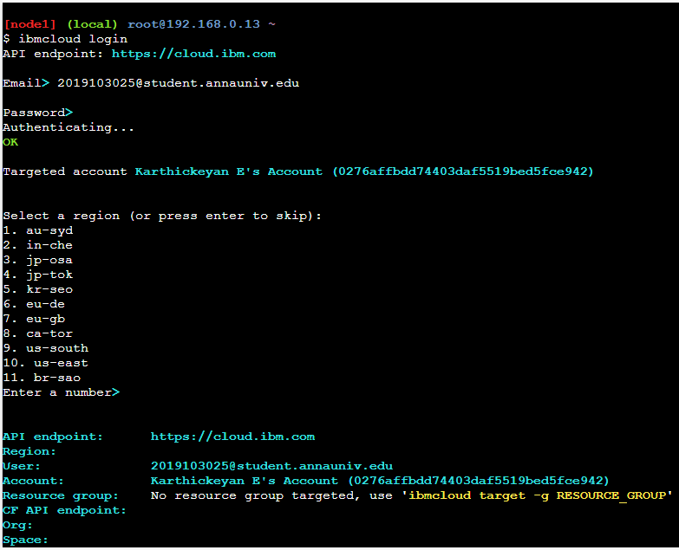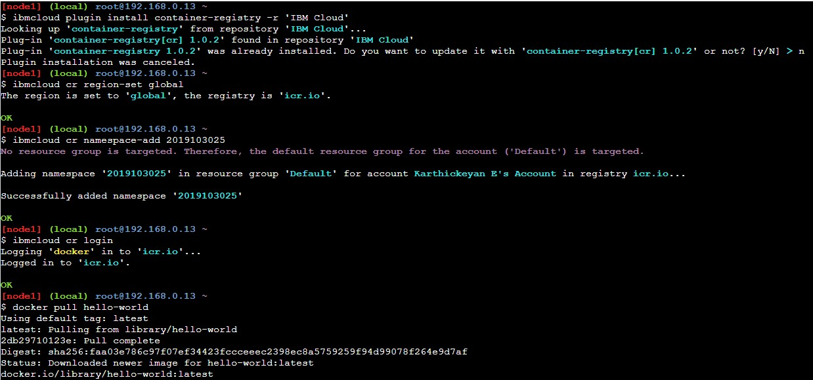

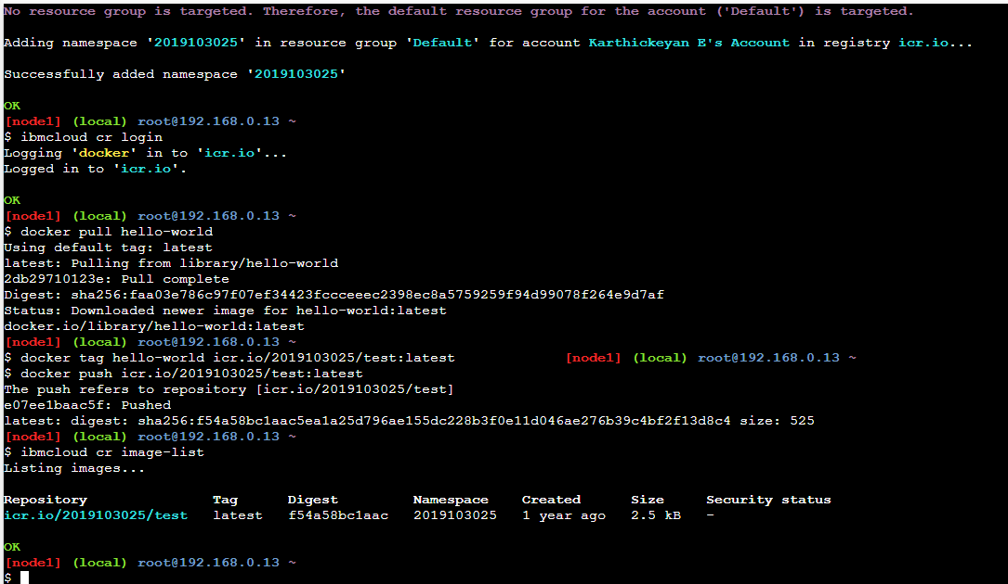

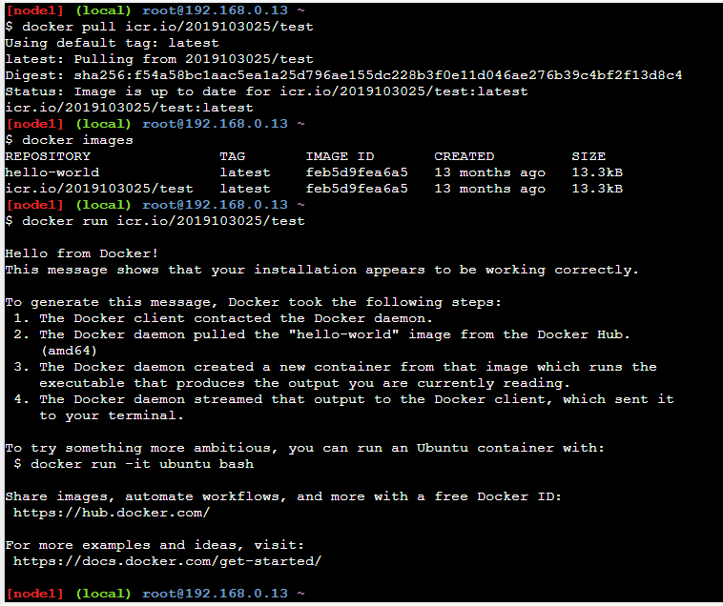

1. Create a Kubernetes cluster in IBM cloud and deploy helloworld image or jobportal image and also expose the same app to run in nodeport.

